# 

# **Accessibility**

Accessibility is a measurement of a users ability to use product /services, the extent to and ease with which they can meet their goals. Designing with accessibility in mind enables people with a range of abilities and disabilities to perceive, understand, negative, interact with, and contribute to the web. A common misconception is that accessibility requires a focus on users that have some kind of disability-but that isn’t the case. Accessibility design is inclusive of everyone. Maximizing ease of use to reach all ability levels leads to products that anyone can use and enjoy, whatever that context. Accessibility design only widens the user pool, and helps all users. The practice of designing to maximize the user pool is know as universal design.

**Example of accessibility:**

An example of accessibility would be any content or functionality that is fully available to and usable by people with disabilities. Common examples of important accessibility features include:

* Image alt text
* Keyboard accessibility
* Sequential heading structure
* Accessible hyperlinks
* Consistent navigation

**Accessibility features are elements specifically designed to improved equal access**

* The best way to approach accessibility is to make it an integral part of content , design, ad coding techniques and processes. Usually therefore, accessibility features are already part of a well- coded website.
* Ensuring accessibility doesn’t have to add extra work or money – start by understanding the basics of accessible design and find ways to incorporate them. Here are some of the most common examples of accessibility features that are also some of the easiest to start improving today.

#### **Image alt text**

Screen readers and other assistive technologies rely on text and so anything that is graphical in nature needs to have a complete text alternative. Some if the most common alt text mistakes include using the word “image ,” skipping the text contained in the image , and including descriptions for purely decorative images.

#### **Keyboard accessibility**

Anything a mouse use can reach , select , or manipulate needs to be available to people who use a keyboard , keyboard emulator , to other input device .full keyboard support is a pillar of an accessible web and while there can be nuance in

technique or key controls , its surprisingly easy to get started trying to test your own website for keyboard accessibility.

#### **Sequential heading structure**

Headings aren’t just design elements they’re critical for navigation and content organization. make sure that headings are coded with actual heading elements (that they don’t just look big or bold) and that they’ re nested in a hierarchy that organize and presents the content as its intended to be read and understood.

#### **Accessible hyperlinks**

Links are the main navigational features of the web experience, letting people move from point to point quickly and easily. however if they aren’t created to be accessible, links can actually present major accessibility barriers. To be accessible, all links should be clear, readable , visually distinct, color contrast compliant , and keyboard accessible.

#### **Consistent navigation**

Consistency in design, layout, and particularly in navigational controls helps people use a website confidently and without unnecessary error . key tips include positioning repeated navigation links in the same location on different pages ,including skips links and using icons and control element s consistently

## Who does this aim to reach out to?

Barriers can be permanent , temporary or situational. They range from people who are completely blind, color blind to those who have low vision . of course it does not only involve visual states , but also people who are deaf, people with mobility impairments or cognitive impairments.

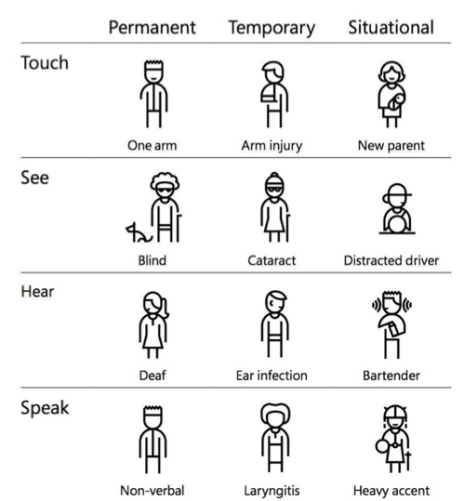**How do we make our designs accessible?**

### Ask yourself where you are and where you need to go

First things first , a baseline measure. Before you start , the accessibility of a current website can be tested using the axe chrome extension.

The web content accessibility guidelines breaks down accessibility into 4 main principles:

* Perceivable : can the content be consumed in different ways?
* Operable: can it function with out confusion and without the use of a mouse or complex interactions?
* Understandable: can a user understand how the user interface of the site functions and the information on the site?
* Robust: can different assistive devices (screen readers , for example) understand the website?

Based on these categories , one can get ratings of A, AA, AAA. 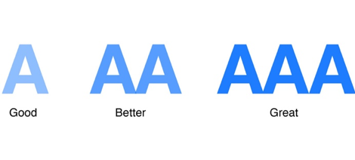

### Be good with color

A best practice here is not to use color as the only visual means of conveying information . one can use tooltips , thick borders, icons , bold, text, underlines, italics, etc. in conjunction with color . This color selector cannot be accessed by a person with any the range of visual impairments from color blindness to complete blindness

### Keep it text-y

People with low vision often make use of screen readers to convert text to speech so that the person can hear the words on a site . a way to allow them to perceive images is using well written and descriptive alt text .another small yet powerful way to assist a screen reader is to add periods in abbreviations (C.I.A. versus CIA). One should offer transcriptions for audio resources , and captions/subtitles for videos. Text blocks with narrow widths are easier to read for all people, especially those with reading or vision impairments . because of this, the WCAG recommends keeping a line of texts character count below 80 characters . also , avoid using justified text and users should be able to zoom into your site 200% without having to scroll horizontally. in terms of content, the WCAG explicitly states that you should aim to write at a ‘lower secondary education level’.

### **Visual cues**

Visual cues are an important aspect of allowing keyboard access. Fonts/ buttons should be large enough to click even with an unstable hand. Allowing users to scroll through links using the TAB key with: focus {outline: 0;} enabled in the backend CSS is another valuable integration . 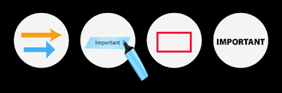

Forms require three specific items that are vital for accessibility: clearly defined boundires, visible labels and helper text- which recent minimalist designs have started to forego . clearly defined boundaries for form fields are important for users with mobility impairments and those with cognitive disabilities. For people with cognitive impairments , keeping a label on a field is important as placeholder text goes away when one types , while labels maintain their usefulness even after.

### Navigation & flow

Hovering excludes keyboard -only interactions. Very often, UX design uses hover for secondary actions and visibility only for primary actions. People who use speech recognition to navigate require actionable items being visible on the screen .allow users more time to enter time-related information. Allow users to go back in the flow if they so require , as mistakes can be made by anybody , but more so by people with some inhibitory factors.

### Test with all users

After all these efforts , is also important to include personas with varying abilities in the testing phase and use accessibility -testing tools(such as WAVE and color oracle) to test the design. And right at the end , one can use this final checklist you can use just to make sure your design is accessible. We are on the brink of creating a new world . we reserve the power to aim for one where every disability is treated like left-handedness -with an ubiquitous and seamless solution , free from stigma. And maybe , just maybe, the physical world will hear us too.